Project Design Phase-II
Technology Stack (Architecture & Stack)
Date | 28 September 2026
Team ID | SWTID-2026-1286
Project Name | Streamlining IT Procurement
Maximum Marks | 4 Marks

Streamlining IT Procurement: Automating Standard Laptop Orders with IT Procurement
The deliverable includes the architectural diagram below and the information as per Table-1 and Table-2. The architecture shows how a standard laptop request raised by an employee flows through the service portal, approval workflow, vendor order integration and asset inventory.
Architecture: Automating standard laptop orders in IT procurement
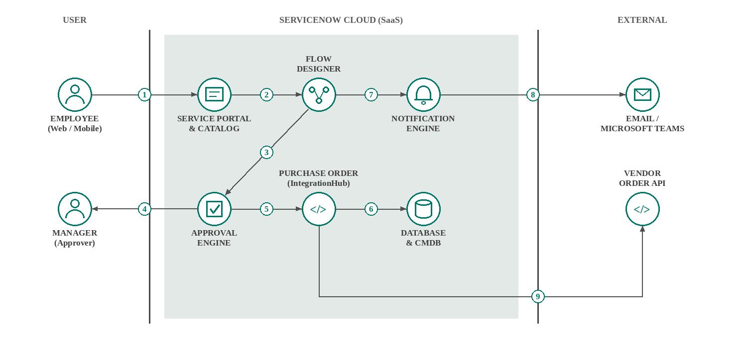
- Employee submits a standard laptop request through the service portal.
- The request triggers a flow in Flow Designer.
- The flow sends the request to the approval engine.
- The manager approves or rejects the request.
- An approved request moves to purchase order creation.
- Order details are stored in the database and CMDB.
- The flow triggers the notification engine.
- Email / Teams notifications are sent to the employee and manager.
- The purchase order is sent to the vendor order API.

Table-1 : Components & Technologies:
S.No | Component | Description | Technology
1. | User Interface | Employees, managers and procurement staff interact with the application through a web portal and mobile app | ServiceNow Service Portal (HTML, CSS, JavaScript, AngularJS), ServiceNow Mobile App
2. | Application Logic-1 | Standard laptop request through a service catalog item with predefined specifications | ServiceNow Service Catalog, Record Producer (JavaScript)
3. | Application Logic-2 | Automated approval workflow that routes each request to the reporting manager, with reminders | Flow Designer, ServiceNow Approval Engine
4. | Application Logic-3 | Automatic purchase order creation and vendor order placement for approved requests | Flow Designer, IntegrationHub (REST)
5. | Database | Stores requests, approvals, purchase orders and laptop catalogue data | ServiceNow platform database (relational)
6. | Cloud Database | Asset and configuration records updated when a laptop is delivered | ServiceNow CMDB and Asset Management
7. | File Storage | Attachments such as quotations, invoices and delivery notes | ServiceNow attachment storage (cloud)
8. | External API-1 | Vendor API to place laptop orders and receive shipment status | Vendor REST API through IntegrationHub
9. | External API-2 | Email and chat notifications to employees and managers on every status change | SMTP email, Microsoft Teams API
10. | Machine Learning Model | Not required for the core solution. Optionally used to forecast laptop demand | ServiceNow Predictive Intelligence (optional)
11. | Infrastructure (Server / Cloud) | Application deployment on Cloud  Local Server Configuration: Not required (browser-based access)  Cloud Server Configuration: ServiceNow cloud instance | ServiceNow Cloud (SaaS)

Table-2: Application Characteristics:
S.No | Characteristics | Description | Technology
1. | Open-Source Frameworks | Open-source frameworks used to build portal widgets and the user interface | AngularJS, Bootstrap
2. | Security Implementations | Single sign-on, role-based access control, encrypted communication and audit logs for approvals and orders | SAML SSO, ACLs and roles, HTTPS/TLS, audit logs, OWASP guidelines
3. | Scalable Architecture | Multi-tier cloud architecture (presentation, application and database) that scales with the number of employees and orders | 3-tier architecture on ServiceNow cloud
4. | Availability | Hosted on cloud with redundant data centres, load-balanced application nodes and automatic failover | ServiceNow multi-instance architecture, load balancers, disaster recovery
5. | Performance | Automated flows process requests within seconds; vendor calls run asynchronously and frequently used data is cached | Flow Designer asynchronous execution, platform caching, CDN

